

**Application Development for Mobile Devices**

**(Comp1661)**

Course Work

|  |  |
| --- | --- |
| **Student Name:** | **Võ Minh Nhựt** |
| **ID Number (FPT CMS):** | **NHUTVMGC60222** |
| **Student Registration # (Greenwich CMS):** | **000901562** |
| **Banner ID (Greenwich CMS):** | **vn6073s** |
| **Student#:** | **GC60222** |
| **Class:** | **GC0763** |

# Abstract

In general, my main aim target in this coursework is to develop a mobile application that will help. During the researching process, I have improved my coding skill as well as my researching skill.

Table of Contents

I. Abstract 2

II. Introduction 4

III. Acknowledgement 5

IV. Concise Table 6

V. Concise List of Bugs 7

1. Removal of Station 7

2. Compatibility Issue 7

3. Facebook Sharing Issue 7

4. Source code size 7

VI. Special Strength 8

VII. Screenshots 9

1. Homepage 9

2. Station Search Result 10

3. Top Station by Facilities’ Rating 10

4. Add New Station 11

5. Station List 11

6. Station Details 12

7. Comments Page 12

8. Station Photos 14

9. About 15

VIII. Evaluation 15

a. HCI Issues 15

b. Maintainability 15

IX. References 15

# Introduction

Modern life comes with modern technologies that have helped us a lot in our daily task. Among that, modern mass transits have showed its ability in providing us a faster, safer and much more convenient way to get to work. From undergrounds to National Rail Ways then the very latest DRL, each and every things is very good on its job, even though there are still weak points about those transportation that have been preventing them to be friendlier to the public.

First of all, as every station do have to acquire to minimum stations’ facility standard but it will be better for both the station managers and travelers to publicly publish to facility information. Since if the travelers know which station have which facilities, not only it will assist them making their decision which station is the best for them, but this also help the station manager aware what their station is lacking of, so that they can easily improve the service quality. Furthermore, it plays an important role in preventing a lot of uncomfortable situations like when a man who had bought a ticket need a disabled access to the platform but it was nowhere to be found.

Secondly, there is no better way to keep an eye on the facilities’ quality than let the customers review it themselves. In this economy doom, customers are very important to the companies, and the most important point in keeping the customers satisfied is to always keep the facilities quality at its peak or at least at an acceptable condition.

Last but not least, the station would be friendlier to the customer if they aware the current quality of the services.

And as a solution for this problem, a mobile application which allows users to point out the available facilities at specific station and review about them is a great way to go.

# Acknowledgement

During the progress doing this coursework, I do really appreciate my lecturer for his enthusiasm in solving my questions and guiding me through this coursework.

# Concise Table

|  |  |
| --- | --- |
| **Feature** | **Implementation** |
| a) | * Fully implemented |
| b) | * Fully implemented |
| c) | * Partially implemented (No Removal of Station) |
| d) | * Implemented but throws an exception if no matching pet is found |
| e) | * Allow photos taken by the camera to be added to the data stored * Make use of Facebook Application to share comments |

# Concise List of Bugs

## Removal of Station

Seems like I could not make the removal function of station become real on time so that I decide not to let the user delete a station at all.

## Compatibility Issue

As Unity Engine built this application to one target system so in order to have this application run as smoothest as it can, I recommended to use Android Platform with API level of 17.

## Facebook Sharing Issue

As my Facebook application has not been approved by Facebook developing team, I have to use an specific account that I have previously added to admin panel of the Facebook app to have the comment posted online.

ID: greenwichesupervisor94@gmail.com

Password: myproject

## Source code size

As the Unity Sourcecode is too big to be uploaded successfully to the assessment hub, I have to upload the apk file and the readme file with the Mediafire link to the full source of this application.

Sorry for this inconvenience but because my sourcecode is too big to be uploaded to the hub so that will you please access this link to download the full source code if you need it:

Mediafire Link :

OneDrive Link : http://1drv.ms/1OEwCeC

# Special Strength

In this mobile application, user can add a new station so they can post their reviews on the station.

Secondly, as if the station has been added before, user can find it by location and get to know its information like: What kinds of facility that the station has? How good are those? How does the station sight look like? What are the comments of the station?

To give more information about my application, as I has successfully implemented Facebook sharing function, through this application, user can publishes their comments directly to their Facebook account so that everybody can read it. But there is a problem that since my Facebook application ( a different part) is still not approved by Facebook developing team so I can only post the comment to Facebook with a Facebook account that has already been added to admin panel of this app. This is the reason for me to create a brand new Facebook account for testing this mobile application.

Furthermore, thanks to Camera Texture built in object, this application also capable of bringing the user a way to describe station sight as they can take a photo of it.

Finally, as this application has been built with Unity Engine, it will definitely have the main characteristic of Unity’s Apps.

# Screenshots

## Homepage

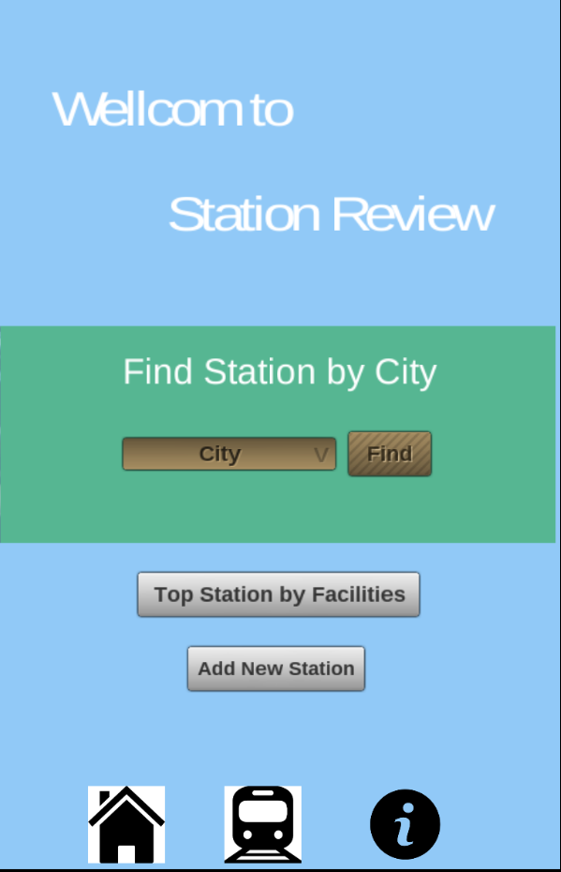

## Station Search Result

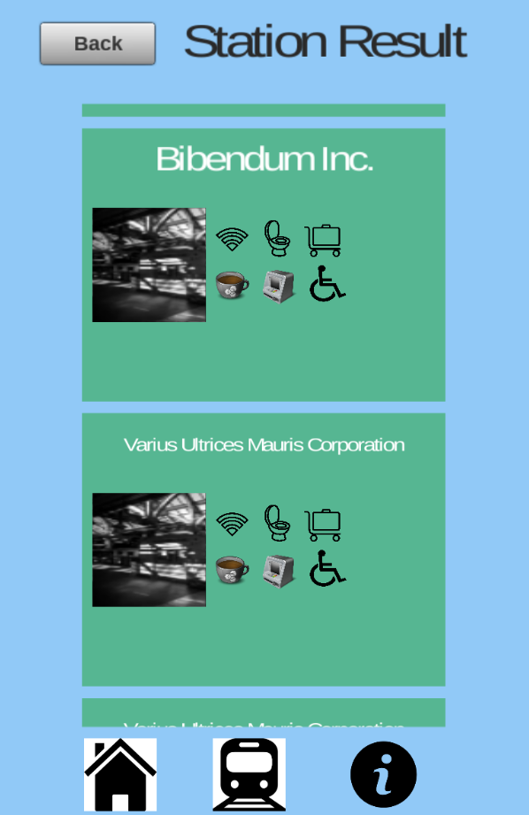

## Top Station by Facilities’ Rating

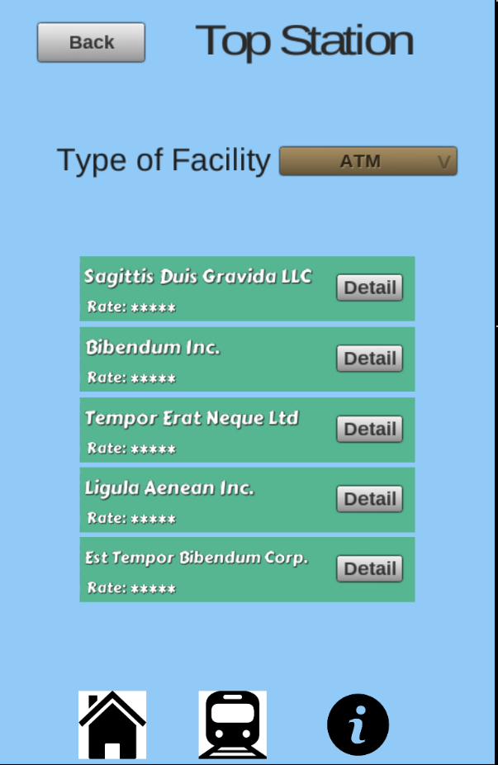

## Add New Station

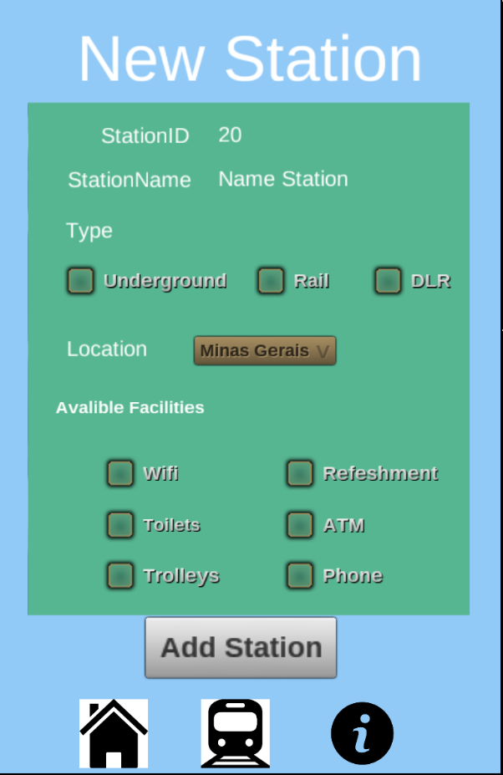

## Station List

* 1. 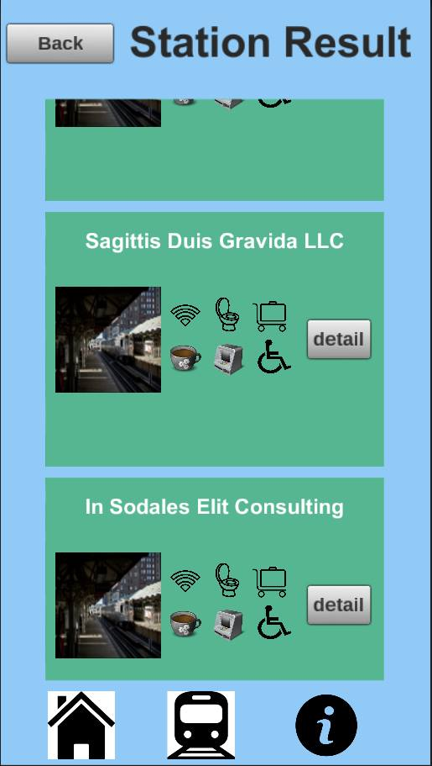

## Station Details

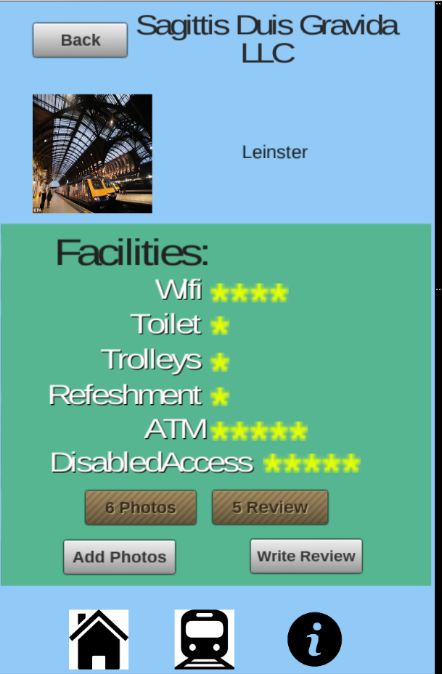

## Comments Page

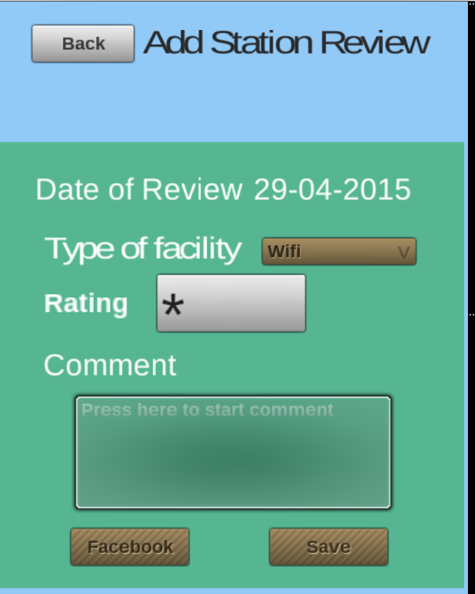

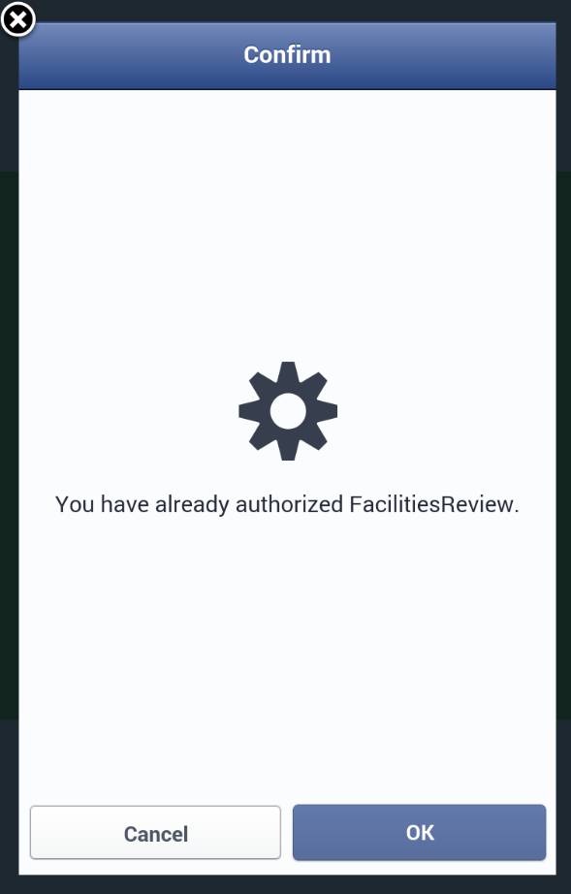

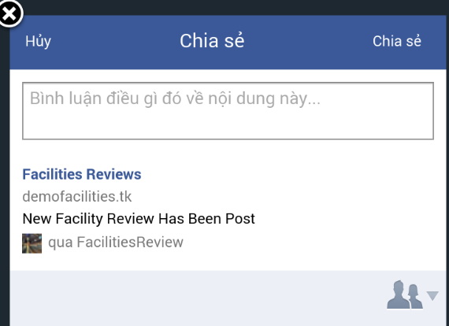

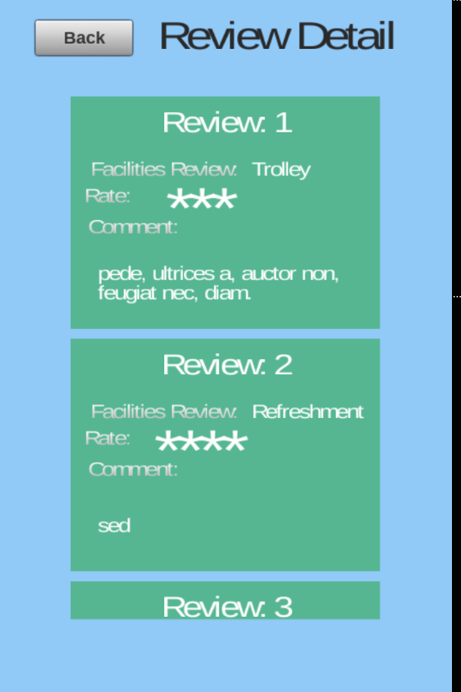

## Station Photos

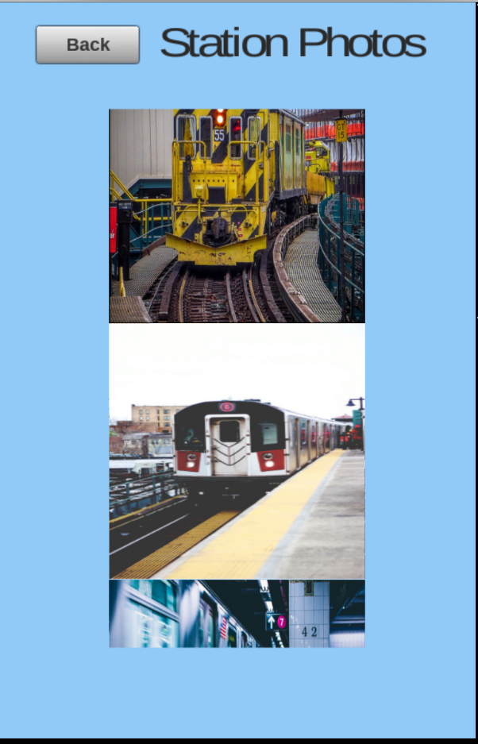

## About

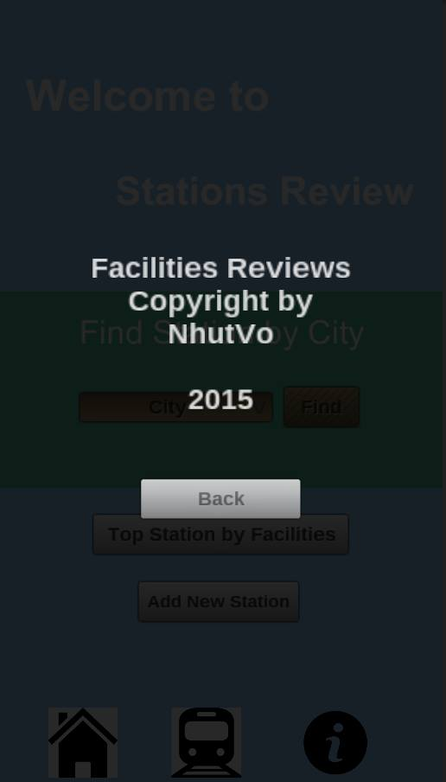

# Evaluation

## HCI Issues

As users usually jump to conclusion and classify an application at the very first moment they open the app, it is highly recommended that not only an application flows must be logical and smooth but the user-interface (UI) must be friendly too.

## Maintainability

This mobile application can be easily maintained because it has been built by Unity engine therefore it is smoothly modifiable

# References